Instructions:

* Please no talking during exam
* This is an open book exam, you can use the Internet, notes, book and or lab materials on canvas.
* Quiz #1 must be submitted before 9:10pm

Good luck!

**There are 11 print screens with code, each worth 9.09%**

**Project #1 (based on Chapter 02)**

Create a program that will ask the user to enter the gross salary (input $80,000.00) as the test data, and then add 10% to the gross salary. Format the output with dollar signs, comma, and periods as shown below.

Expected outcomes is $88,000.00

**#1 print screen the output with code below here.**

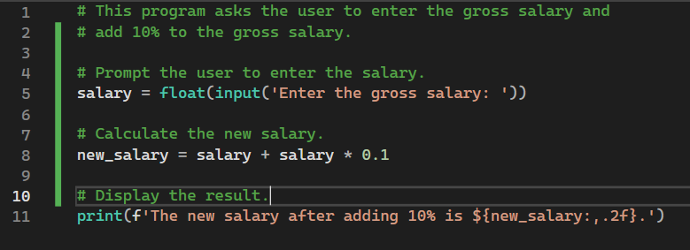

**Project #2 (based on Chapter 02)**

Create a program that will ask the user to enter 5 scores (use 60, 70, 80, 90) then sum the scores, and then average the scores as well.

Expected outcomes is: sum = 300, average = 75

**#2 print screen the output with code below here.**

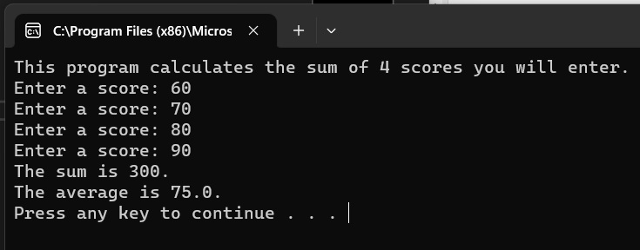

**Project #3 (based on Chapter 02)**

Create a program that will ask the user to enter the first and last name, with age, and output the results.

Be sure to use your criteria for the input.

Expected outcomes is: Jason Sim, 45

**#3 print screen the output with code below here.**

**Project #4 (based on Chapter 03)**

Create a program that will ask the user to enter the Sales, and then display the commission. See table below: Use the If statement.

|  |  |
| --- | --- |
| **In sales** | **Commission** |
| $50,000.00 - $60,000.00 | 10% |
| $70,000.00 - $80,000.00 | 20% |
| $90,000.00 - $100,000.00 | 30% |

**#4 print screen the output with all possible commissions below here**

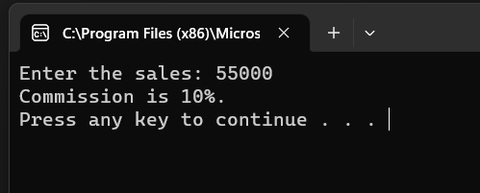

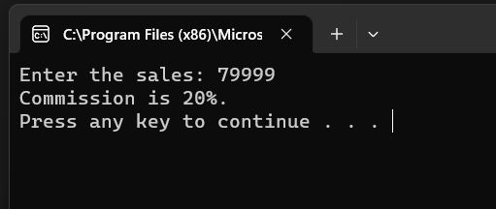

**#5 print screen the code below here.**

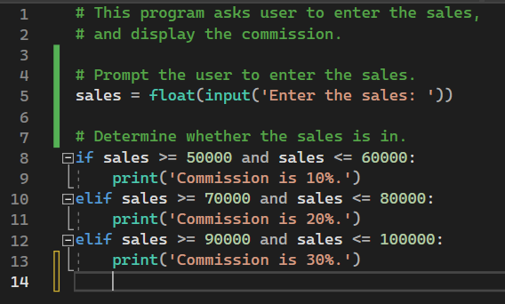

**Project #5 (based on Chapter 03)**

Project #5 is an extension of Project #4, Create a program that will ask the user to enter the Sales then multiply the salary with commission, and finally add the results to the salary. See table below: Use the If statement. The more sales are sold the more commission is given.

Data Set to enter:

* Enter $65,000.00 >> expected outcome >> $77,000.00
* Enter $76,000.00 >> expected outcome >> $96,000.00
* Enter $98,000.00 >> expected outcome >> $127,400.00

|  |  |  |
| --- | --- | --- |
| **In sales** | **Salary** | **Commission** |
| $50,000.00 - $60,000.00 | $70,000.00 | 10% |
| $70,000.00 - $80,000.00 | $80,000.00 | 20% |
| $90,000.00 - $100,000.00 | $90,000.00 | 30% |

**#6 print screen the output with all possible combinations below here**

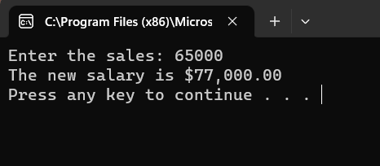

**#7 print screen the code below here.**

**Project #6 (based on Chapter 04)**

Create a program that will ask the user to enter a grade score (4 scores) and output the letter grade associated with the average grade. *Then using a* ***while*** *loop, if the average is greater than 100, inform the user to re-enter the 4 scores.*

|  |  |
| --- | --- |
| If the average is between 90-100 | Than receive a letter grade of (A) |
| 80-89 | B |
| 70-79 | C |
| 60-69 | D |
| Below 60 | F |

**#8 print screen the average for letter grade (A) below here.**

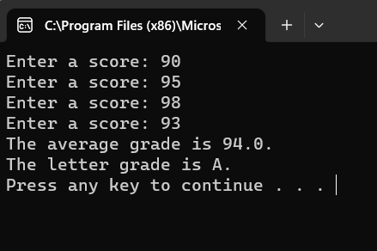

**#9 print screen when the average is greater than 100 below here.**

**#10 print screen your entire code below here.**

**Project #7 (based on Chapter 04)**

Using the for loop, create a program that will sum the numbers 1 – 10.

**#11 print screen the output with code below here.**

**Submit this document to Module 4 Quiz #1.**